**SQL SERVER HEALTH REPORT**

**22-12-2016**

**MS-DB01-PRD**

**ALL MY SONS**

**Email:Sanjeev@allmysons.com**

The MS-DB01-PRD Server Sql server all services are running

* Server is running
* Sql Server Agent running
* Sql Browser is running

**JOBS**

* Last 24 Hours All jobs are ran successfully

**Backups**

* All backups’ jobs running
* We don’t have backup for Jazz database (offline)

**Drives free space:**

**drive MB free**

C 883096

D 259256

E 470016

F 208148

G 1401836

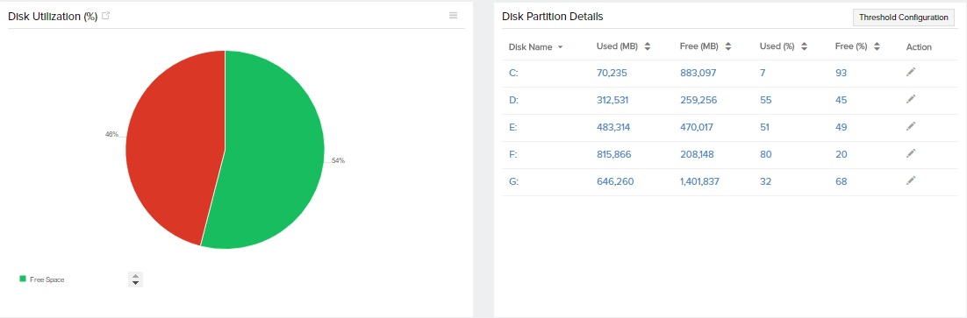

We have enough space in all drives except D drive (250GB),On every Sunday AMS database log file size goes to 20-25GB ,if any other databases log files sizes increases ,we might be go to out of space.

Recommendation: Choose the 1TB drive

Now we are not using the F drive , we need take a proper action on F drive.

D drive have good performance

**CPU utilization**

CPU utilization is Normal

Max: 96 Min:0 Avg:22

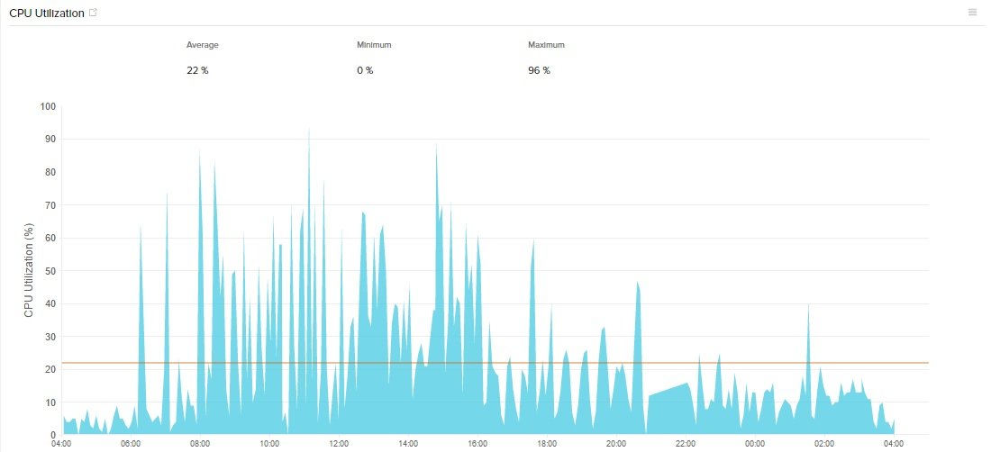

**Memory Utilization**

Memory utilization is varying from 91-94% .

Sql server always usages the 54GB ,The system memory utilization is varying every time

Total RAM: 65GB

SQL server : 54GB

Available RAM: 4.4GB

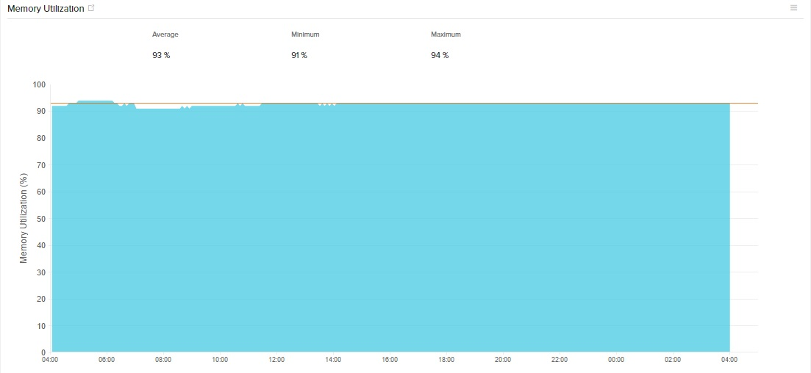

**Auto Growth disable Log file list:**

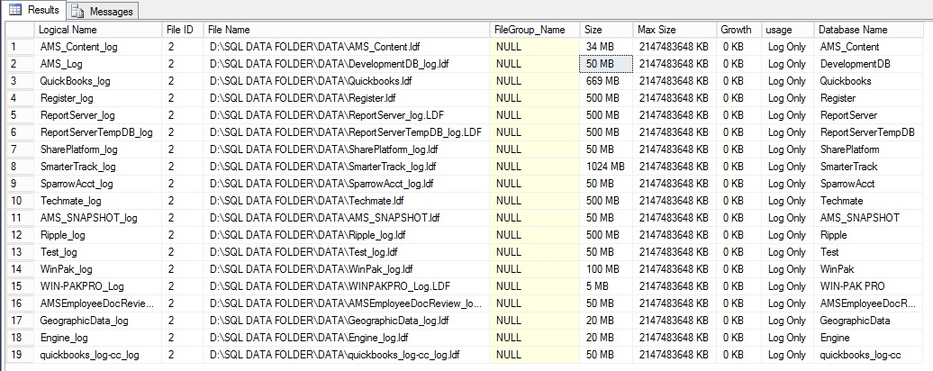

**Auto Growth =1024KB databases**

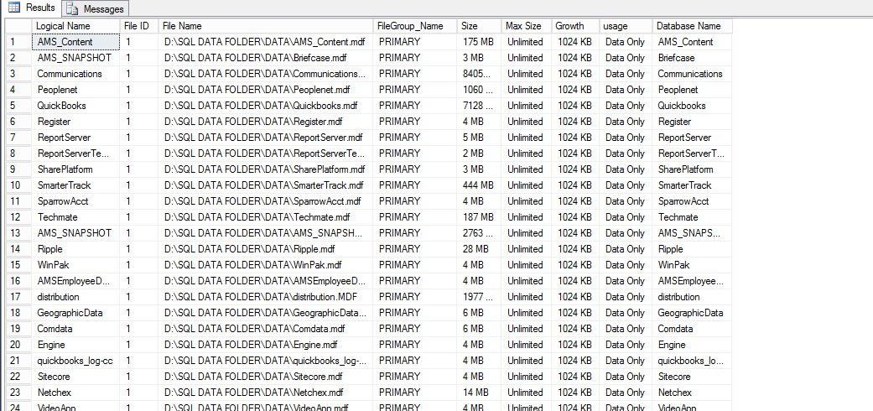

**Batch request:**

Min:0

Avg:231

Max:451

(Last 24 Hours)

**Active connections:**

Min:78

Avg:220

Max:352

(Last 24 Hours)

**Buffer cache hit ratio**:99%

Page Life Expectancy: Avg:38145 seconds

**Blocking**

Since One week we don’t have blockings (not more than 5 minutes)

**Wait Types On Server**

Top wait types on Server

Server Restart

The SQL Server Last restarts on November 30

Reason: Windows Updates